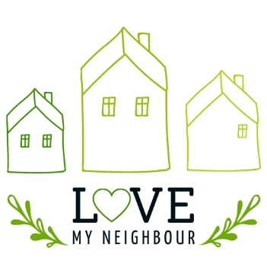
Goody Bag
Shopping List

By giving a thoughtful, prayerfully prepared gift bag, we can bless our older neighbours, build bridges for future connection, and maybe even opportunities to share the gospel.
These could be bought for and put together individually, or in bulk my groups and churches.
A few ideas of what the gift bags could contain:
- A Personal Note or Christmas Card: A warm, handwritten message expressing care and offering prayer can make a huge impact. It could include an invitation to a church service or event if appropriate
- Sweet Treats
  - Hot chocolate or Cappuccino sachets: Something warm and comforting for cold days
  - Festive chocolates or mince pies
- Savoury Treats
- Crackers and Cheese
- Homemade or shop bought chutney
- Children’s pictures or crafts: If you have children in your household or your church has children’s groups, why not get them to paint or make something for you to include in the goody bag
- Spiritual Resources
  - A Bible or scripture-based booklet – see here for ideas
  - A Christian magazine e.g. Hope or Good News Newspaper
  - A flyer featuring the DailyHOPE phone number 0800 8048044
- A festive home addition
- Poinsettias can be bought at reasonable prices in supermarkets at this time
- A shop bought or handmade decoration is a lovely touch to include in the bag
- Practical Gifts
  - Lip balm or hand cream
  - Warm socks or gloves
- Entertainment
  - A puzzle book or magazine: Something to keep minds active and engaged
  - A small craft kit: If you know the neighbour enjoys activities like knitting or adult colouring, a craft kit can be a delightful addition
- A Local Resource Guide: If your church offers seniors events or there are community support services (like Warm Hubs or social groups), include a flyer or information sheet

- An Invitation: This could be an invitation to a church event, carol service, or Christmas meal. Or it could be a personal invitation to your home or for an outing to a garden centre or similar

