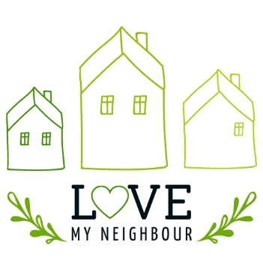
Goody Bag
Shopping List

By giving a thoughtful, prayerfully prepared gift bag, we can bless our older neighbours, build bridges for future connection, and maybe even opportunities to share the gospel. These could be bought for and put together individually, or in bulk my groups and churches.
A few ideas of what the gift bags could contain:
- A Personal Note or card: A warm, handwritten message expressing care and offering prayer can make a huge impact. It could include an invitation to a church service or event if appropriate
- Sweet Treats
  - Hot chocolate or Cappuccino sachets, or variety tea bags: Something warm and comforting
  - Old fashioned sweets or seasonal treats
- Savoury Treats
- Crackers and Cheese
- Homemade or shop bought chutney
- Children’s pictures or crafts: If you have children in your household or your church has children’s groups, why not get them to paint or make something for you to include in the goody bag
- Spiritual Resources
  - A Bible or scripture-based booklet or bookmark – see here for ideas
  - A Christian magazine e.g. Hope or Good News Newspaper
  - A flyer featuring the DailyHOPE phone number 0800 8048044
  - A holding cross – wooden or palm at Easter time
- A seasonal home addition
- Poinsettias in December or tulips in the new year can be bought at reasonable prices in supermarkets
- A wax or battery operated tealight with a little glass holder candle to bring light in this dark season
- Practical Gifts
  - Lip balm or hand cream
  - Warm socks or gloves
- Entertainment
  - Word search, crossword or trivia sheets or booklets: Something to keep minds active and engaged
  - A small craft kit: If you know the neighbour enjoys activities like knitting or adult colouring, a craft kit can be a delightful addition
- A Local Resource Guide: If your church offers seniors events or there are community support services (like Warm Hubs or social groups), include a flyer or information sheet

- An Invitation: This could be an invitation to a church event, special service, or meal. Or it could be a personal invitation to your home or for an outing to a garden centre or similar

