CHRISTMAS ANGELS KNITTING PATTERN

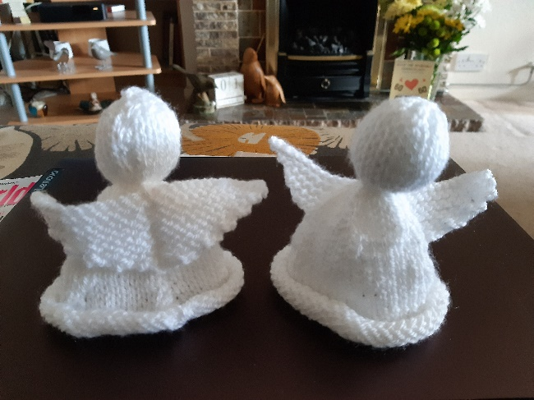

What you will need:

- Some DK wool
- Knitting needle size 9 (3 ¾)
- Darning needle (like a big sewing needle)
- Small amount of stuffing (a cotton wool ball for the head, perhaps)
You will need a basic knowledge of knit and purl to make these angels, but don’t let that stop you if you haven’t done it before. It’s never too late to learn a new skill!
The angels have been designed to be as simple and as flexible as possible, so everyone from a beginner to a more advanced knitter can have a go.
Feel free to adapt the pattern if you want by using different colours/types of wool, or adding features to personalise them.
We have used size 9 needles with double knitting wool to knit some of ours.
Angel’s Body
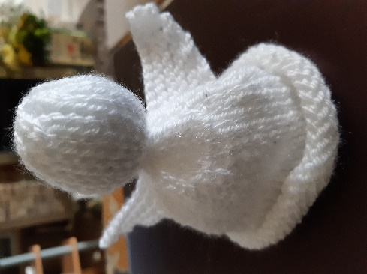
Cast on 48 sts (stocking stitches)
1. Knit row
2. Purl row
3. K2TOG, K10*, repeat until end
4. Purl row
5. Knit row
6. P2TOG, P9*, repeat until end
7. Knit row
8. Purl row
9. K2TOG, K8*, repeat until end
10. Purl row
11. Knit row Angel with Option 1 wings
12. P2TOG, P7*, repeat until end
13. Knit row
14. Purl row
15. K2TOG, K6*, repeat until end
16. Purl row
17. Knit row
18. P2TOG, P5*, repeat until end
19. Knit row
20. Purl row
21. K2TOG, K4*, repeat until end - 20 sts
22. Purl row
23. Knit row
24. Purl row
25. Knit row
26. Purl row
27. Knit row

At this point, you can change your colour to create the face if you want.
28. Purl row
29. Knit row
30. Purl row
31. Knit row
32. Purl row
33. Knit row
34. Purl row
35. K2TOG - repeat until end
36. Purl row
37. Knit row
38. P2TOG - repeat until end
Using a darning needle, thread the end of the yarn through the stitches and tighten to create the top of the head. Turn the angel inside out and sew up the head and the body. Around the neck, take a small amount of stuffing and place at the top of the head, then thread some yarn between stitches and pull loosely together.
Angel’s Wings
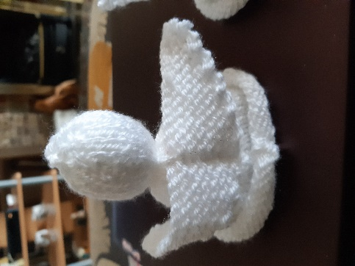
Cast on 27 sts
1. Knit row
2. Knit row
3. Decrease at each end (Knit)
4. Knit row
5. Knit 12 rows, decrease at each end cast off
Sew wings to the body.

